AP Calc WS#5 Limits involving Infinity Name: ______

Limits by algebraic simplification: The substitution rule cannot be used to evaluate $\lim_{x→c}f(x)$ if c is not in the domain of the function f (for instance, if it produces a zero in the denominator).

 

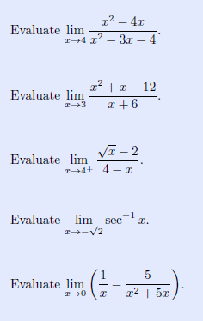

The symbol for infinity (∞) does not represent any real number. When we say “the limit of f as x approaches infinity” we mean the limit of function f as x moves increasingly far to the right on the number line.

Facts: When the *denominator* approaches zero then the *fraction* approaches infinity

When the *denominator* approaches infinity then the *fraction* approaches zero

$\lim_{x→+∞}\frac{1}{x}=?$ $\lim_{x→-∞}\frac{1}{x}=?$ We say $\lim_{x→∞}\frac{1}{x}=?$

We say the line y = 0 is a **horizontal asymptote** of the graph f(x) = 1/x.

Check with your calculator.

Prove the horizontal asymptote of $f(x)=2+\frac{1}{x}$ is the line y = 2

Use graphs and tables to find $\lim_{x→+∞}f(x)$, $\lim_{x→-∞}f(x)$ identify all horizontal asymptotes of $f(x)=\frac{x}{\sqrt{x^{2}+1}}$

Find the following limit and sketch its graph to support your answer

$\lim_{x→0}\frac{1}{x}=$ $\lim_{x→∞}(1+\frac{1}{x})=$ $\lim_{x→∞}\frac{\sqrt{3}}{x^{2}}=$

$\lim_{x→0+.}(\frac{1}{x^{1/3}})=$ $\lim_{x→0-.}(\frac{1}{x^{1/3}})=$ $\lim_{x→1+.}(\frac{1}{x-1})=$ $\lim_{x→1-.}(\frac{1}{x-1})=$

We say the line x = a is a **vertical asymptote** of the graph f(x) if either

$\lim_{x→a^{+.}}f(x)=±∞$ or $\lim_{x→a^{-.}}f(x)=±∞$

Find the vertical asymptotes of the following, Describe the behavior to the left and right of each vertical asymptotes

a. $f(x)=\frac{1}{x^{2}}$ b. f(x) = tan x

Find the following limits. Hint divide

a. $\lim_{x→-∞}\frac{-15x}{7x+4}=?$ b. $\lim_{x→∞}\frac{{5x}^{2}+8x-3}{{3x}^{2}+2}=?$

c. $\lim_{x→-∞}\frac{11x+2}{{2x}^{3}-1}=?$ d. $\lim_{x→∞}\frac{{2x}^{2}-3}{7x+4}=?$

e. $\lim_{x→∞}\frac{-{4x}^{3}+7x}{{2x}^{2}-3x-10}=?$ f. $\lim_{x→-∞}\frac{-{4x}^{3}+7x}{{2x}^{2}-3x-10}=?$

Find the following limits. Hint: Using properties (cheatsheet)

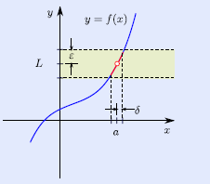

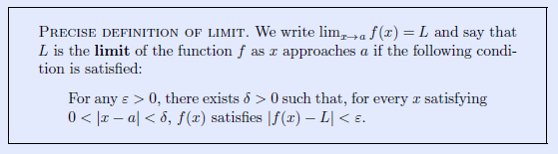





Use squeeze theorem to show that

There are functions that you can't take limit algebraically, then using tabular method will help.

a. $\lim_{x→1}x^{1/{(x-1)}}=?$ Use 6 decimals number

|  |  |  |  |  |  |  |
| --- | --- | --- | --- | --- | --- | --- |
| 0.9 | 0.99 | 0.999 | 1 | 1.001 | 1.01 | 1.1 |
|  |  |  |  |  |  |  |

b. $\lim_{x→0}\frac{3^{x}-1}{x}=?$ Use 6 decimals number

|  |  |  |  |  |  |  |
| --- | --- | --- | --- | --- | --- | --- |
| -0.1 | -0.01 | -0.001 | 0 | 0.001 | 0.01 | 0.1 |
|  |  |  |  |  |  |  |

c. $\lim_{x→0}\frac{1-cos(x)}{x^{2}}=?$ Radian mode. Use 6 decimals number

|  |  |  |  |  |  |  |
| --- | --- | --- | --- | --- | --- | --- |
| -0.1 | -0.01 | -0.001 | 0 | 0.001 | 0.01 | 0.1 |
|  |  |  |  |  |  |  |

d. $\lim_{x→0}\frac{tan(2x)}{5x}=?$ Radian mode. Use 6 decimals number

|  |  |  |  |  |  |  |
| --- | --- | --- | --- | --- | --- | --- |
| -0.1 | -0.01 | -0.001 | 0 | 0.001 | 0.01 | 0.1 |
|  |  |  |  |  |  |  |